**Practical – 8**

1. **Ensure that your login has following tables with proper constraints and data:-**

**COURSE Table**

| **CourseCode** | **CourseName** | **CourseFees** | **Department** |
| --- | --- | --- | --- |
| 101 | MCA | 80000 | MCA |
| 102 | MBA | 60000 | MBA |
| 103 | Btech | 75000 | Engg |
| 104 | BCA | 30000 | MCA |
| 105 | BSc(IT) | 25000 | MCA |
| 106 | MSc(IT) | 35000 | MCA |
| 107 | BBA | 22000 | MBA |

**STUDENT Table**

| **RollNo** | **Name** | **City** |
| --- | --- | --- |
| 1 | Amit | Delhi |
| 2 | Sumit | Goa |
| 3 | Shweta | Gwaliar |
| 4 | Kumar | Goa |
| 5 | Puneet | Meerut |
| 6 | Bharat | Gwaliar |

**REGISTER Table**

| **RollNo** | **CourseCode** |
| --- | --- |
| 2 | 101 |
| 4 | 103 |
| 5 | 101 |
| 3 | 105 |
| 1 | 103 |

**Solution :**

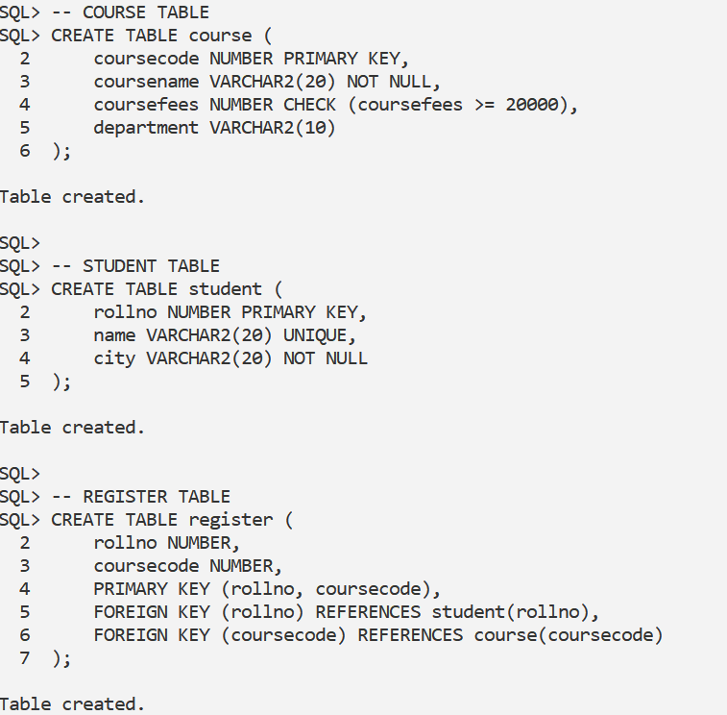

1. Write queries for the following:-
2. Display **complete details of students** who are **not registered** in any course.

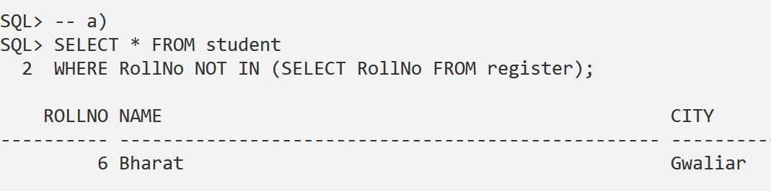

1. Show only the **Roll numbers** of students **not registered** in any course.  
     
   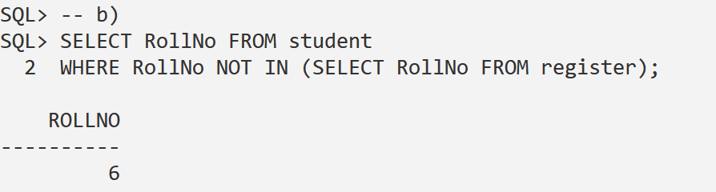

1. Show **details of students** who are registered in courses from the **"MCA" department**.  
     
   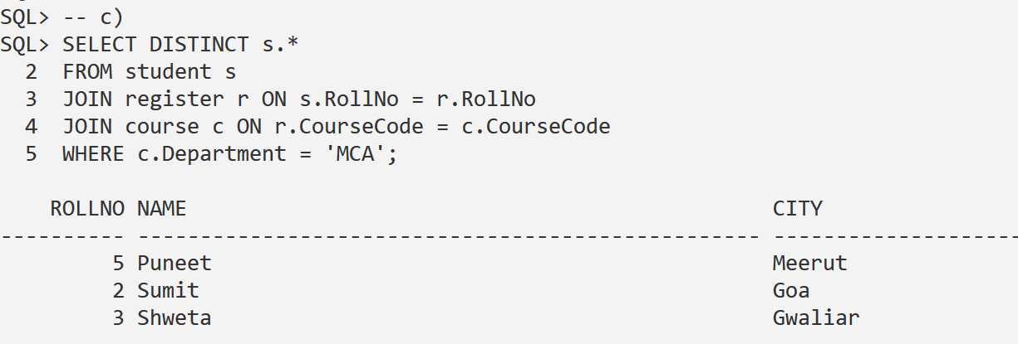
2. List **courses** in which **no students are registered**.  
     
   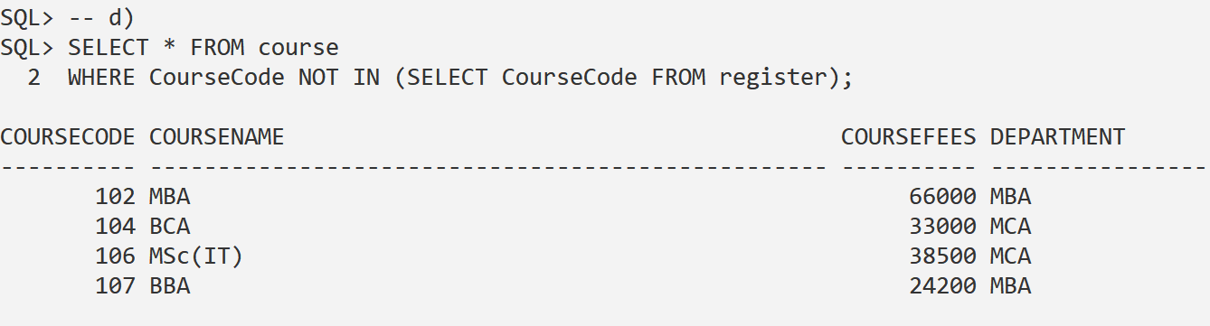
3. List **courses** in which **at least one student is registered**.  
     
   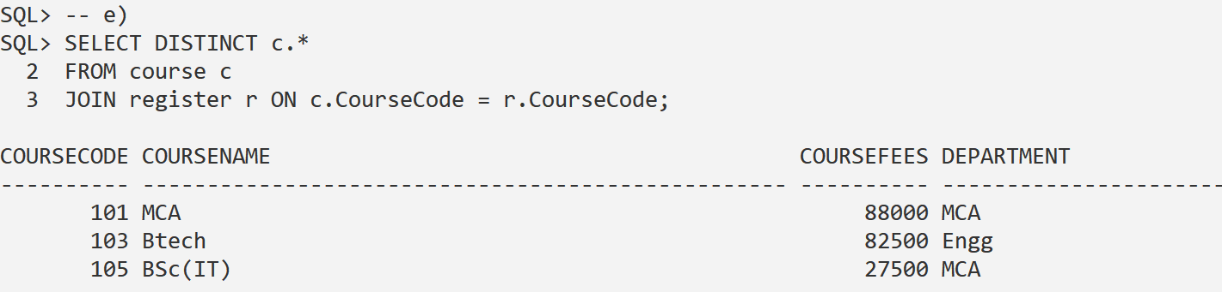
4. List **students** who are registered in **courses having fees greater than "BCA"**.  
     
   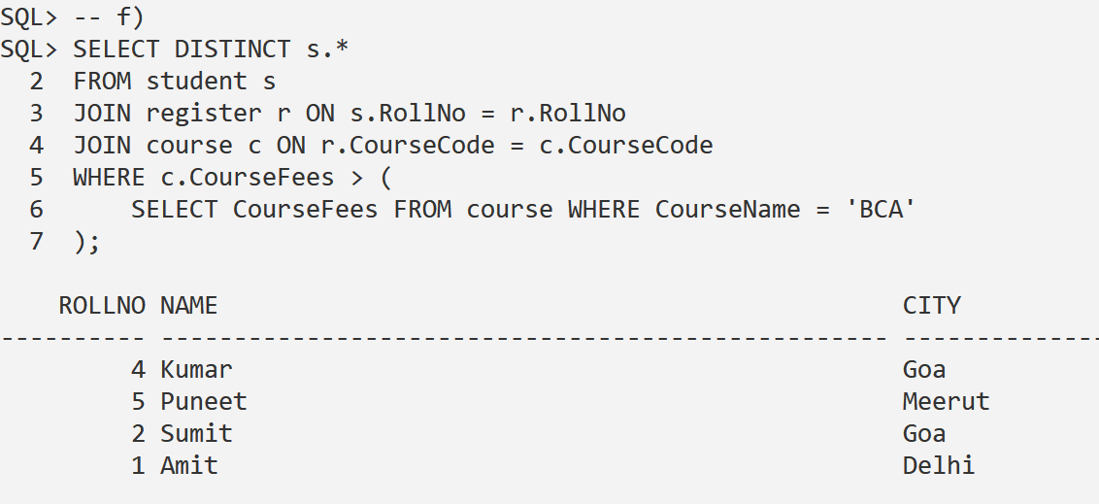
5. Show the **total fees** and **average fees** of all courses.  
     
   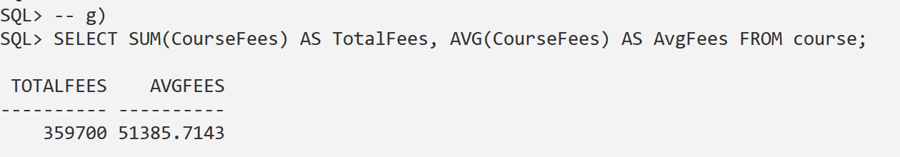
6. Display **department-wise total course fees**.  
     
   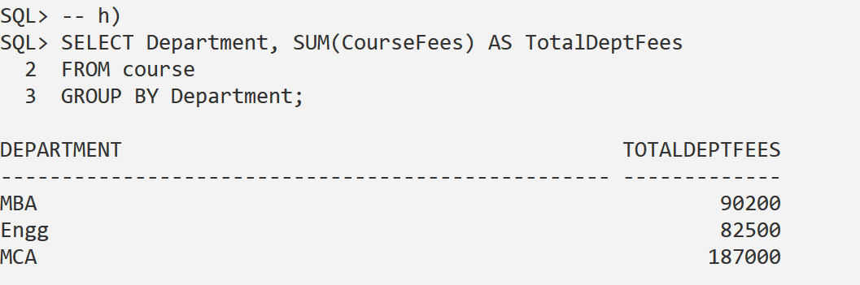
7. Show the **maximum course fee** in each department.  
     
   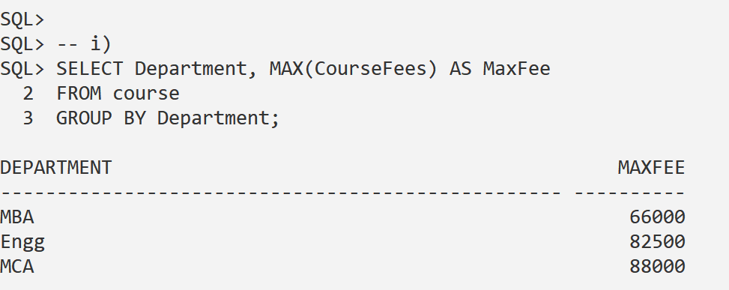
8. Display **course details** with **fees greater than average course fee**.

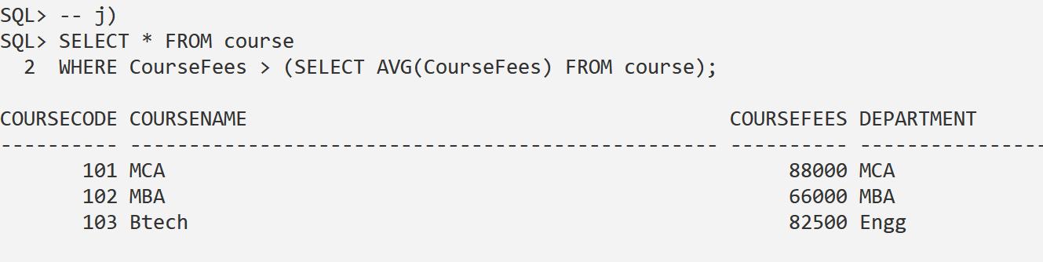

1. Show **details of courses** in which **students from "Goa"** are registered.  
     
   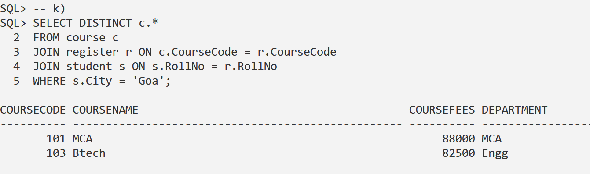
2. **Increase course fees by 10%** for all courses and **commit** the changes.  
     
   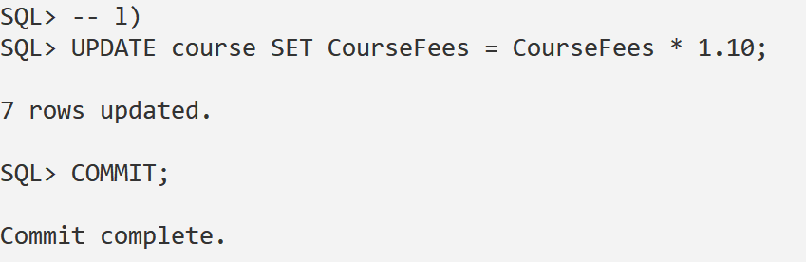
3. View **all records** from the course table.  
     
   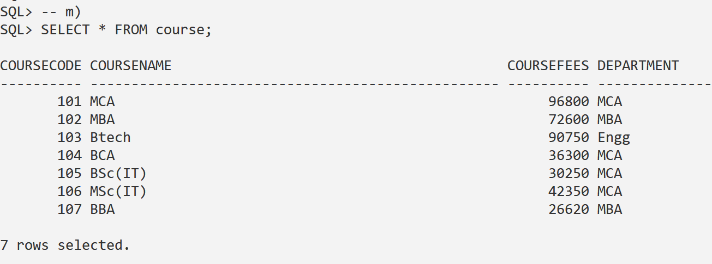
4. Display the **highest, lowest, and average course fees**.  
     
   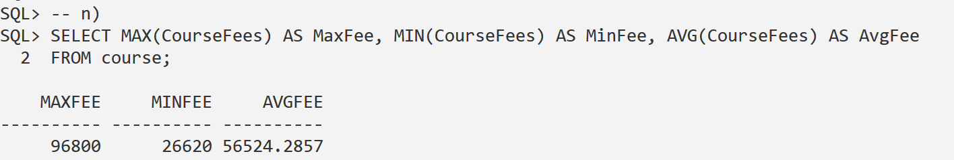
5. List the **names of students** registered in courses with **fees less than 30000**.  
     
   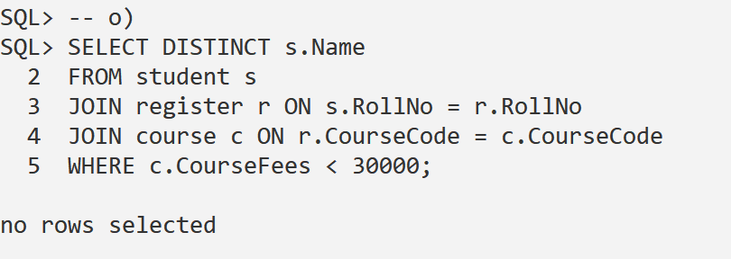
6. Display **course codes** along with the **total number of student registrations** in each.  
     
   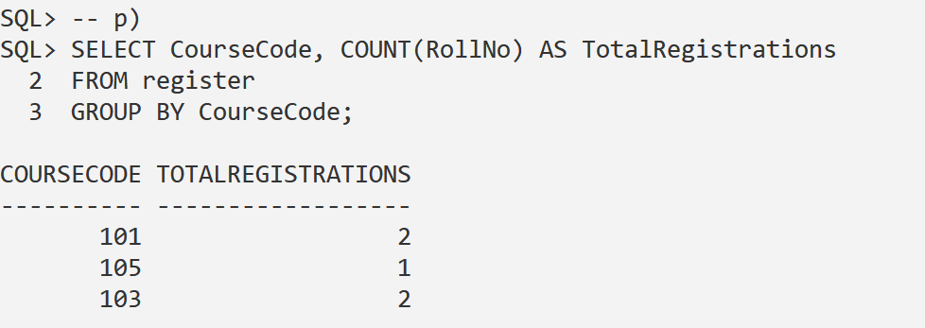
7. Show the **total number of students from "Goa"**.  
     
   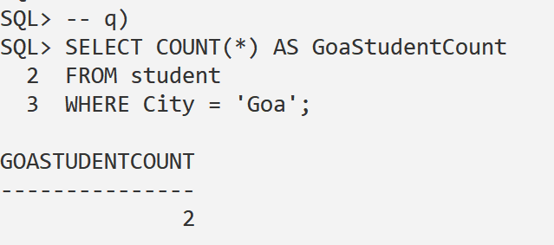
8. Display the **highest course fee**.  
     
   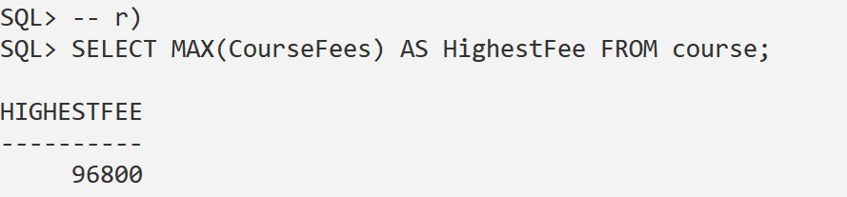
9. Display the **second highest course.**

